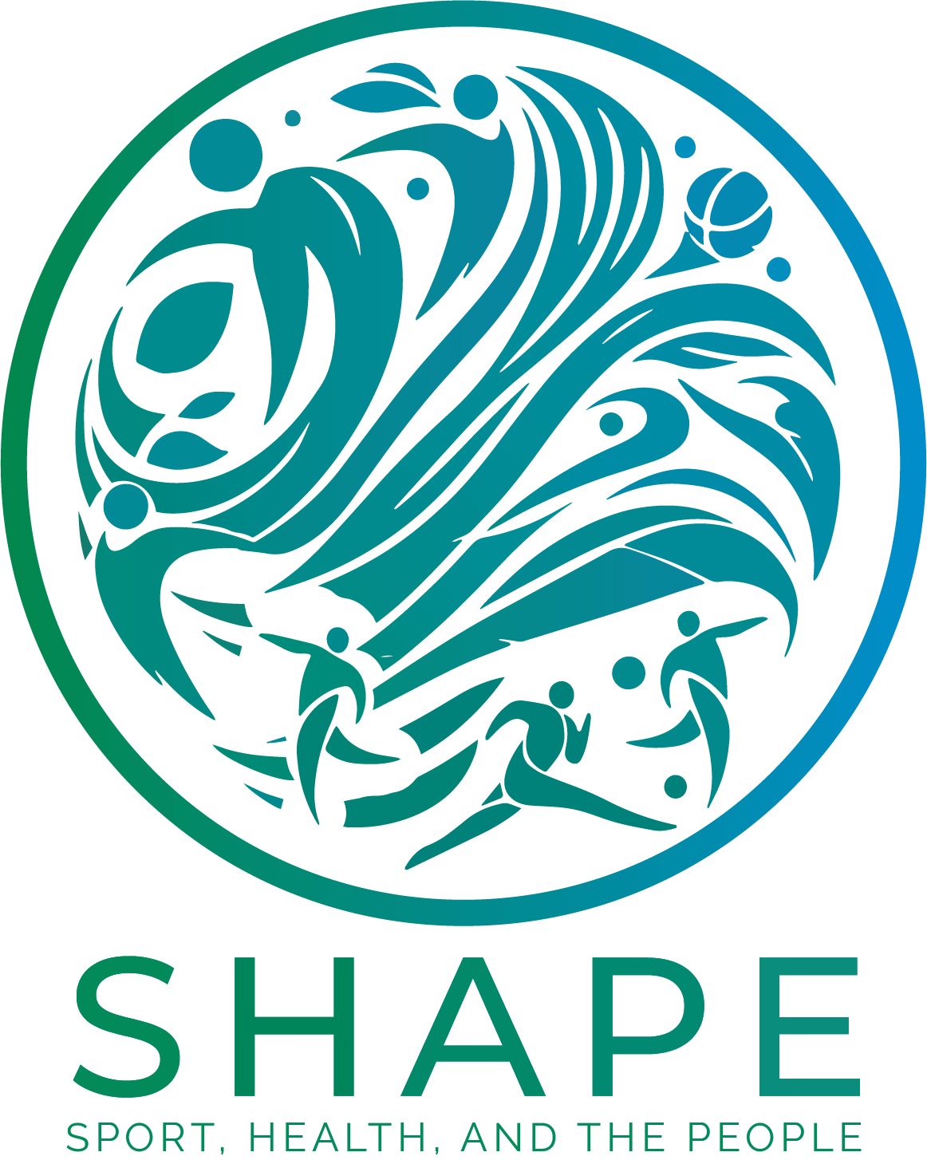

SHAPE – Building a Western Balkan University Network in Sports
101128787
ERASMUS-EDU-2023-CBHE-STRAND-1
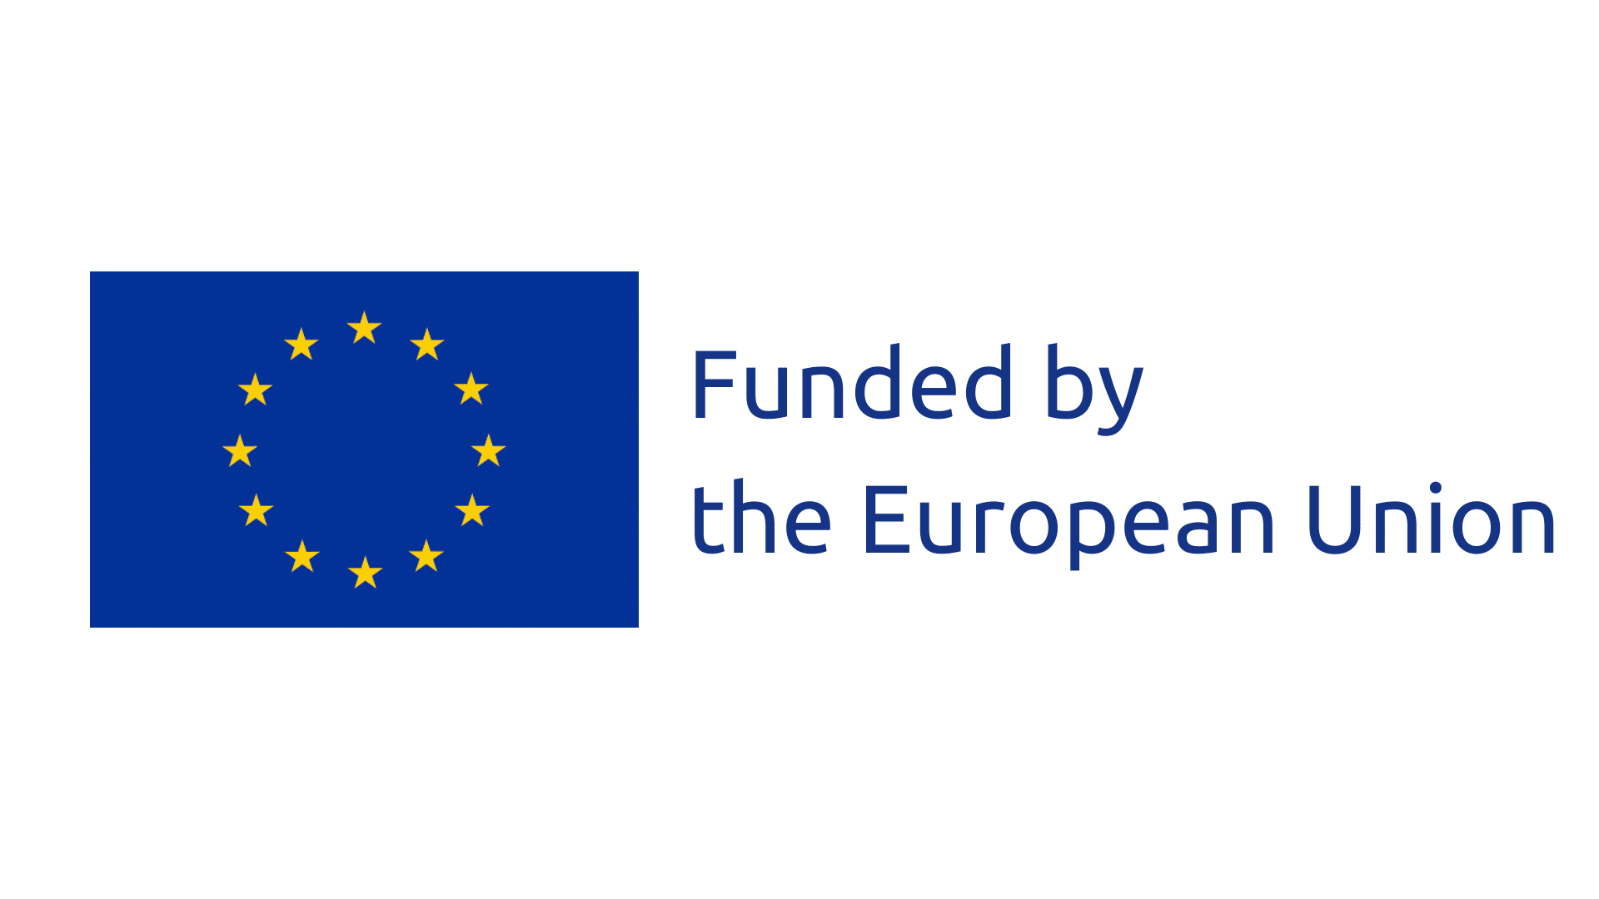

Deliverable Report:
Project Name: SHAPE – Building a Western Balkan University Network in Sports
Project Code: 101128787
Funding Program: ERASMUS-EDU-2023-CBHE-STRAND-1

ABOUT SHAPE PROJECT:

The project is aimed to build-up a University Network on Sport in Western Balkans, and design joint actions, in line with the European context and EU recommendations, to promote an active lifestyle in the population, and contribute to community life and sustainable development in the Region. To this effect, the project aims to train sport professionals qualified in specific sport fields as applied to the different needs, and promote personal health, as well as common values such as inclusion, equality, safety, or environmental awareness, thereby contributing to community life and to a peaceful social development.

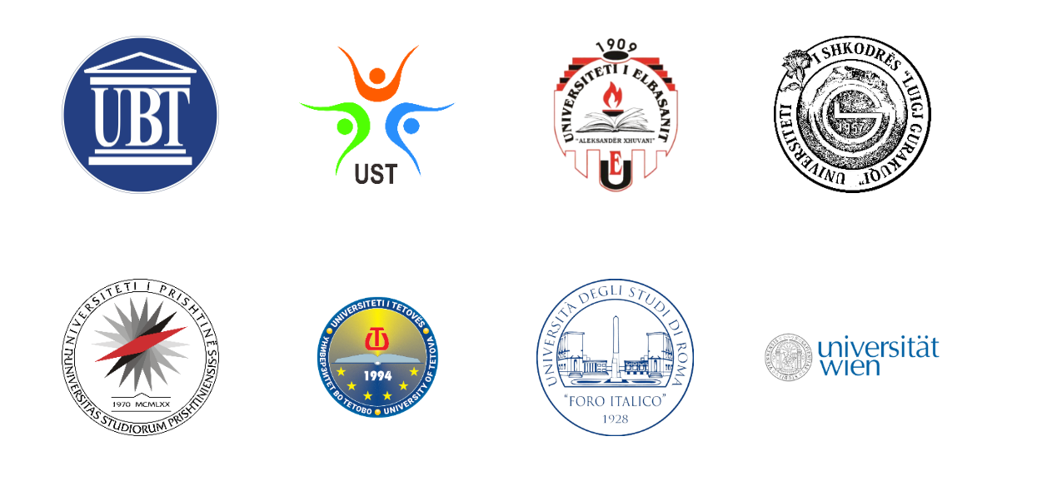

Contents
1. Introduction Error! Bookmark not defined.
2. Objectives Error! Bookmark not defined.
3. Conclusion Error! Bookmark not defined.

Tabel of content can be tailored depending on the report

